LABORATORIYA ISHI №4
Mavzu: PHP orqali MySQL ma’lumotlar bazasiga ulanish
1. Ishning maqsadi
- Tayyor MySQL bazaga PHP orqali ulanish
- SELECT so‘rovlarini bajarish
- INNER JOIN orqali bir nechta jadval ma’lumotlarini chiqarish
- MySQLi (procedural, OOP) va PDO usullarini taqqoslash
- Ular orasidagi farqlarni amaliy ko‘rsatish

2. Nazariy qism
PHP orqali MySQL bilan ishlashning 3 asosiy usuli mavjud:
- MySQLi (Procedural)
- MySQLi (Object-Oriented)
- PDO (PHP Data Objects)


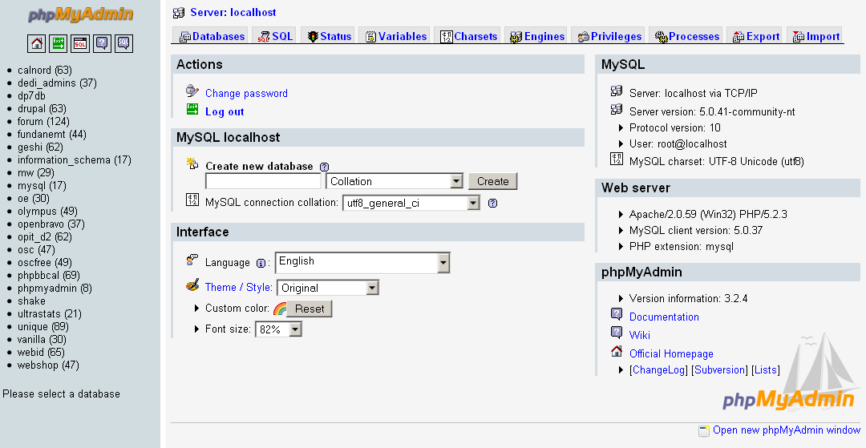

3. Amaliy baza (tayyor database)
Database: db_universitet
3 ta jadval:
fakultetlar
- id (PK)
- nomi
talabalar
- id (PK)
- ism
- kurs
- fakultet_id (FK)
fanlar
- id (PK)
- fan_nomi
- kredit
- talaba_id (FK)

4. Oddiy SELECT so‘rovi
SELECT * FROM talabalar;

5. JOIN so‘rovi
SELECT
talabalar.ism,
talabalar.kurs,
fakultetlar.nomi AS fakultet,
fanlar.fan_nomi
FROM talabalar
INNER JOIN fakultetlar ON talabalar.fakultet_id = fakultetlar.id
INNER JOIN fanlar ON talabalar.id = fanlar.talaba_id;

6. PHP orqali ulanish usullari
6.1 MySQLi – Procedural usul
<?php
$conn = mysqli_connect("localhost", "root", "", "db_universitet");
if (!$conn) {
die("Ulanish xatoligi: " . mysqli_connect_error());
}
$sql = "SELECT * FROM talabalar";
$result = mysqli_query($conn, $sql);
while ($row = mysqli_fetch_assoc($result)) {
echo $row['ism'] . " - " . $row['kurs'] . "<br>";
}
mysqli_close($conn);
?>
Xususiyatlari:
- Oddiy
- Faqat MySQL bilan ishlaydi
- Xavfsizlik PDO ga qaraganda pastroq
6.2 MySQLi – Object Oriented usul
<?php
$conn = new mysqli("localhost", "root", "", "db_universitet");
if ($conn->connect_error) {
die("Xatolik: " . $conn->connect_error);
}
$sql = "SELECT * FROM talabalar";
$result = $conn->query($sql);
while ($row = $result->fetch_assoc()) {
echo $row['ism'] . "<br>";
}
$conn->close();
?>
Xususiyatlari:
- OOP yondashuv
- Professionalroq
- Katta loyihalar uchun qulay
6.3 PDO usuli (Tavsiya etiladi)
<?php
try {
$conn = new PDO("mysql:host=localhost;dbname=db_universitet", "root", "");
$conn->setAttribute(PDO::ATTR_ERRMODE, PDO::ERRMODE_EXCEPTION);
$sql = "SELECT * FROM talabalar";
$stmt = $conn->query($sql);
while ($row = $stmt->fetch(PDO::FETCH_ASSOC)) {
echo $row['ism'] . "<br>";
}
} catch(PDOException $e) {
echo "Xatolik: " . $e->getMessage();
}
?>
Xususiyatlari:
- Turli DB lar bilan ishlaydi (MySQL, PostgreSQL, Oracle)
- Eng xavfsiz
- Prepared Statement kuchli
- try-catch bilan ishlaydi

7. PDO orqali JOIN misoli
<?php
try {
$conn = new PDO("mysql:host=localhost;dbname=db_universitet", "root", "");
$conn->setAttribute(PDO::ATTR_ERRMODE, PDO::ERRMODE_EXCEPTION);
$sql = "SELECT
talabalar.ism,
talabalar.kurs,
fakultetlar.nomi AS fakultet,
fanlar.fan_nomi
FROM talabalar
INNER JOIN fakultetlar
ON talabalar.fakultet_id = fakultetlar.id
INNER JOIN fanlar
ON talabalar.id = fanlar.talaba_id";
$stmt = $conn->query($sql);
echo "<table border='1'>";
echo "<tr><th>Ism</th><th>Kurs</th><th>Fakultet</th><th>Fan</th></tr>";
while ($row = $stmt->fetch(PDO::FETCH_ASSOC)) {
echo "<tr>
<td>{$row['ism']}</td>
<td>{$row['kurs']}</td>
<td>{$row['fakultet']}</td>
<td>{$row['fan_nomi']}</td>
</tr>";
}
echo "</table>";
} catch(PDOException $e) {
echo "Xatolik: " . $e->getMessage();
}
?>

8. Usullarni taqqoslash
Xususiyat | MySQLi Procedural | MySQLi OOP | PDO
DB turi | Faqat MySQL | Faqat MySQL | Ko‘p DB
Xavfsizlik | O‘rtacha | Yaxshi | Eng yaxshi
try-catch | Yo‘q | Yo‘q | Bor
Prepared | Bor | Bor | Juda kuchli
Professional | O‘rtacha | Yaxshi | Eng yaxshi

Mustaqil Topshiriq

Elektron jurnal
Database: db_jurnal

Jadvallar:
fanlar
- id
- nomi
talabalar
- id
- ism
baholar
- id
- talaba_id (FK)
- fan_id (FK)
- baho

JOIN vazifa:
Talaba + Fan + Baho chiqarish.

Talaba nima qiladi?
- Baholar jadvali orqali bog‘laydi
- 3 jadval JOIN
- HTML jadval chiqaradi
<?php

error_reporting(E_ALL);
ini_set('display_errors', 1);

// Bazaga ulanish parametrlari
$host = "localhost";
$user = "root";
$password = "";
$database = "jurnal_db"; // E’tibor bering, bazamiz endi jurnal_db

// Ulanish yaratish
$conn = new mysqli($host, $user, $password, $database);

// Ulashni tekshirish
if ($conn->connect_error) {
die("Bazaga ulanishda xatolik: " . $conn->connect_error);
}

// JOIN so‘rovi – talabalar + fanlar + baholar
$sql = "SELECT
talabalar.ism AS talaba,
fanlar.nomi AS fan,
baholar.baho
FROM baholar
JOIN talabalar ON baholar.talaba_id = talabalar.id
JOIN fanlar ON baholar.fan_id = fanlar.id";

$result = $conn->query($sql);
?>

<!DOCTYPE html>
<html>
<head>
<meta charset="UTF-8">
<title>Elektron Jurnal</title>
<style>
body { font-family: Arial; margin: 30px; }
h2 { color: #333; }
table { border-collapse: collapse; width: 60%; }
th, td { border: 1px solid #999; padding: 10px; text-align: center; }
th { background-color: #eee; }
tr:nth-child(even) { background-color: #f9f9f9; }
tr:hover { background-color: #d1e7fd; }
</style>
</head>
<body>

<h2>Talabalar Baholari</h2>

<table>
<tr>
<th>Talaba</th>
<th>Fan</th>
<th>Baho</th>
</tr>

<?php
if ($result && $result->num_rows > 0) {
while($row = $result->fetch_assoc()) {
echo "<tr>
<td>".htmlspecialchars($row['talaba'])."</td>
<td>".htmlspecialchars($row['fan'])."</td>
<td>".(int)$row['baho']."</td>
</tr>";
}
} else {
echo "<tr><td colspan='3'>Ma’lumot topilmadi</td></tr>";
}

$conn->close();
?>
</table>

</body>
</html>
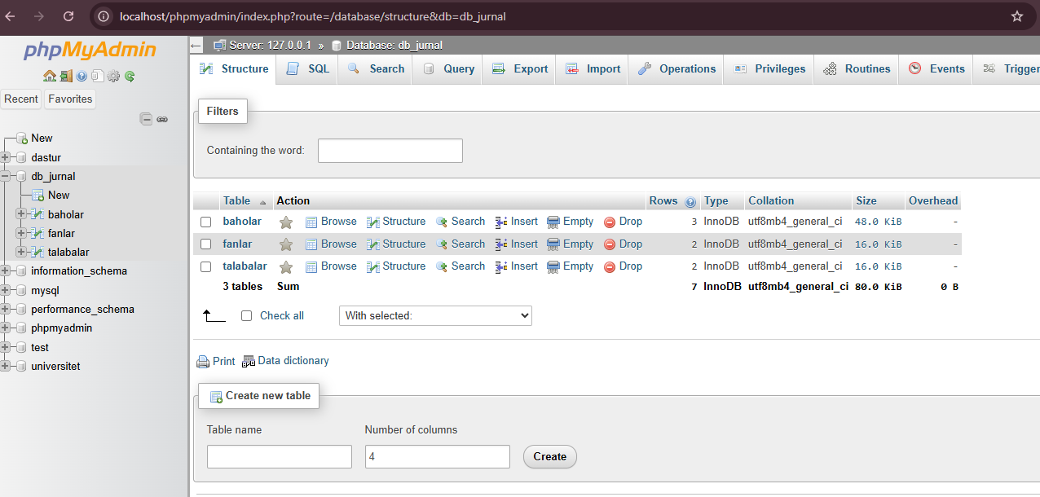
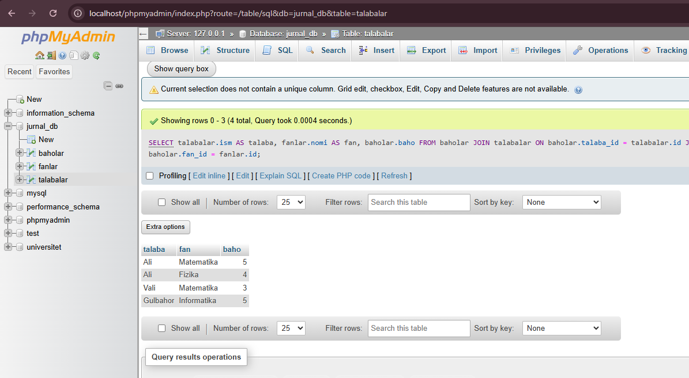
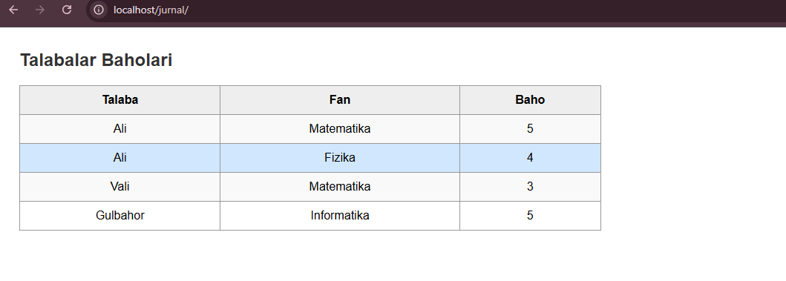

Xulosa
Ushbu laboratoriya ishida PHP dasturlash tili orqali MySQL ma’lumotlar bazasiga ulanish, so‘rovlar yuborish hamda natijalarni olish jarayoni batafsil o‘rganildi. Ma’lumotlar bazasi zamonaviy veb-ilovalar uchun muhim qism ekanligi, unga to‘g‘ri ulanish va ma’lumotlar bilan ishlash dastur samaradorligini belgilovchi omil ekanligi aniqlandi.
Laboratoriya davomida MySQL serveriga ulanish uchun kerakli parametrlar (host, foydalanuvchi, parol, baza nomi) qanday berilishi va ulanish obyekti (mysqli yoki PDO) yaratish bosqichlari ko‘rsatildi. Ulanishning muvaffaqiyati yoki xatolik holatlari qanday tekshirilishi, shuningdek, xatoliklarni aniqlash uchun PHP-da xatolarni ko‘rsatish sozlamalari (error_reporting) qanday yoqilishi misollar bilan berildi.
Ma’lumotlarni olish uchun SQL SELECT so‘rovlari yozilishi va ularni PHP yordamida qanday bajarish tushuntirildi. Ayniqsa, bir nechta jadvallarni bog‘lovchi JOIN operatorlari orqali murakkab so‘rovlarni bajarish amaliyoti o‘rganildi. Ushbu yondashuv yordamida talabalar, fanlar va baholarni o‘zaro bog‘lab, ma’lumotlar bazasidan tizimli ma’lumotlarni olish mumkinligi ko‘rsatildi.

